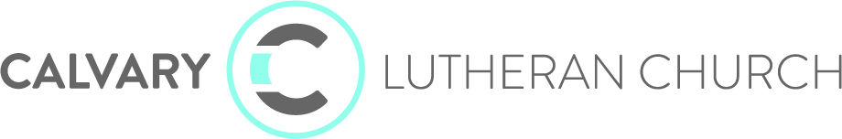

Approved Council Minutes for March 21, 2022

Meeting called to order by Jana Berndt at 6:02 pm on Monday, March 21.

Mission Sightings
- Success of “28 Days of Acts” study through church. Over 200 people signed up.
- Success of Hope Haven at Calvary. 120 volunteers who brought meals, stayed overnight and supported in other ways.
- 8 new Connect Groups added and getting ready to start soon.

Consent Agenda
- Consent Agenda proposed for approval, no fund approvals. Marc Sugden motioned, 2nd by Tyler Geyen. Motion carries.

Treasurer Report
Presented by Bruce Luehmann
- Worship income is running about $10,000 over budget, so Feb was a good financial month.
- Moved some money from checking into designated accounts. Will allow us to make additional principal payment on the building loan. We are ahead of schedule on the repayment of the building loan.
- We are still up on our investments, even though with the economy moving the endowment fund down a little bit.
- Treasurer’s report proposed for approval. Frank Peterson motioned, 2nd by Clay Ostlund. Motion carries.

Strategic Focus
- Reviewed the article “The New Metrics: 9 Church Statistics that Pastors Should Start Tracking”
  - What are the “old” ways we used to track if the church is doing well? What are different metrics we should be looking at now post-Covid? What are our true indicators of success?
  - The church is planning on doing a survey with the congregation through the Barna Group and connect that to our strategic plan.
  - Took time to focus on our Strategic Priorities (Connect, Kid and Student Ministry, Online Ministry, Partner Network, Community, and Leadership) and ideated around things we are doing well and things we could improve upon. More details to come as we organize the thoughts over the coming months.
  - Pastor Hans will meet with the staff to get their thoughts and then we will decide on the 3 focus areas for the next 6 months to focus on vision and strategic priorities with leanings toward Leadership and Online Ministry.

Old Business
- Each year requires an audit of financials, this year’s is coming up for the 2021 books. We typically do internal audits for 3 years and then an external on the 4th. We are looking to add one more person to the audit committee.
  - Nominations to the audit committee were made. Motion to ask one of those members to join the audit committee was made by Tyler Geyen, 2nd by Marc Sugden. Motion carries.
- Easter
  - There will be four services for Easter this year, plus a Maundy Thursday and Good Friday service. All were encouraged to invite people to join us.
  - Invitation cards will be given out detailing upcoming events leading up to Easter and the schedule for Holy Week.
- Preschool Update
  - Condolences and celebration of life for Connie Good and everything she has done for our preschool. Katie Rentschler is now leading the preschool as we hire for the Director position. Teacher Sarah Olson is on a leave of absence due to a return of her cancer.
- Staffing updates
  - Hired Mitch Kaeter to join our custodial team.

New Business
- New Worship Series after Easter is Here to There. God is always moving us forward from one place to the next. Excited to start that out.
- Calvary at The Lake is coming! Approx 70 days away!
- Next Steps - Video Announcement Project
  - Pre-recorded video announcements featuring different members of the church each week. These will welcome people to worship and also give the two or three key things to know for the week.

3 Take Aways
- Ideation and time on Strategy and vision.
- Easter is coming up - invite someone!
- Great engagement with Calvary from our community.

The meeting closed with Pastor Hans leading in prayer and adjourned at 8:20 pm.

