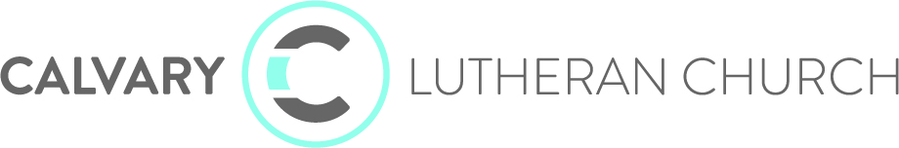

UNAPPROVED COUNCIL MINUTES OCTOBER 18, 2021
Members present: Pastor Hans, Angie Larson Executive Pastor, Katie Rentschler, Bruce Luehmann, Tyler Geyen, Deb Dittberner, Jana Berndt, Frank Peterson, Kathy Hungness, and Jennifer Rentz
Members Absent: Marc Sugden and Lukas Gotto
The meeting was called to order at 5:21 p.m. by Vice President Tyler Geyen. No additions to the agenda were made. Pastor Hans led us in prayer.
Mission shout outs and wins: We had a tremendous response from people giving food for the food shelf. In the last 2-3 months Calvary has given 30 gifts to new visitors to our church. Our Wednesday night student ministry attendance has increased since last year and 30% of the total children involved are new to Calvary.
STRENGTHENING OUR MISSION AND VISION FOR MINISTRY
Strategic Priorities:
2021-2022 Priorities: Kid and Student Ministry continues to search for a leader. Tomorrow a second candidate will be interviewed with a third candidate being interviewed next week. The first candidate that was interviewed will be back for a second interview on the 30th.
Online Church is going strong. We continue to pause in hiring an online minister.
Partner Church Network continues to move forward. Currently they are developing agreement contracts to be utilized in the partnership process. The Partner Church Network is also having conversation with the Bishop of the NW MN Synod.
Supporting our Priorities:
Communication of Strategies/Mission/Vision/Values conversation continues to move forward. Our last meeting with the consultants is tonight. We will be discussing the communication piece.
Financial Planning: Covid Catch Up Appeal Update; we are making good progress with the appeal. Approximately $34,000 has come in in addition to the $25,000 individual donation.
2022 Stewardship General Fund Appeal Update: Those figures were not readily available at the meeting but auto giving is increasing.
Next Gen Minister/Kid & Student Ministry: see above. A special shout out/thanks to Cheryl Whitchurch who is doing a super job helping with this ministry.

SUPPORTING OUR MISSION AND VISION
Consent agenda: A fund approval request for $1500 from the Senior High Youth Trip Fund for the 2022 Houseboat trip to Rainy Lake was entertained. Motion was made by J. Rentz, seconded by K. Hungness, and carried to approve the consent agenda which consisted of the fund approval, September council minutes and the staff reports.
Treasurer’s Report:
September Financials: Bruce shared the September financials. Our YTD General Fund Worship Income is 15% below YTD Budget. Our expenses are right in line with budget. Our YTD Net General Fund Income shows us at $29,164 due to recording the $126,000 of income from the PPP monies we received. We had gains in returns of the Calvary Partner Network monies invested in Edward Jones. These positive return monies will be moved into a lower risk account. A payment of $400,000 will be made to the building expansion loan #1 and $17,000 will be paid to the Endowment Fund. Motion was made by K. Hungness, seconded by J. Rentz, and carried to approve the September financials.
Old Business:
Building Project Timeline: The final payment and retainage fee (monies we held until the HVAC was fixed) will be completed at the end of the month.
Covid Update: Calvary staff and leadership continue to encourage mask wearing while attending Calvary. Dr. Dittberner reported on the uptick in Covid, decrease and/or lack of available hospital beds locally and regionally, and the adjustments Alomere Hospital has made to accommodate.
New Business
Christmas Worship Themes: The theme for Christmas 2021 at Calvary is: A Weary World Rejoices.
Advent Calendar and Christmas Worship: Giving Tree will be the first few weeks of Advent. Kids and Carols will be held December 5 at Calvary. Carols and Cocktails will be December 9 at Gathered Oaks.
Christmas Worship Schedule was discussed preliminarily as: Wednesday, December 22 at 6:30 pm; Thursday December 23 at 6:30 pm; Friday, December 24 at 11 am, 1 pm, 3 pm, and 5 pm; Sunday, December 26 - online worship only. The traditional service will be at the 11 am service on Friday, December 24 with the other services being modern (the traditional Christmas songs will be sung at all of the services).

SENT OUT TO SERVE
Leadership Dates:
November 15 at Calvary
December 13 at Calvary
Prayer and Adjournment: The meeting was adjourned at 6:03 p.m.

